**What is JSP?**

* JSP is Sun's solution for developing dynamic web sites. JSPs provide a way to separate the generation of dynamic content (java) from its presentation (html).
* JSP provide excellent server side scripting support for creating database driven web applications.
* JSP enable the developers to directly insert java code into jsp file, this makes the development process very simple and its maintenance also becomes very easy.
* Servlets generate the content as well as the necessary HTML syntax to present them to the browser. JSPs differentiate content from presentation.
* JSPs appear like an HTML document, embedded with JSP specific tags and have a file extension “.jsp”.
* The JSP directives are responsible for generating dynamic content while HTML part takes care of formatting and presentation.
* JSPs are ultimately implemented as Servlets.
* A “.jsp” file is always compiled to servlets when they are loaded for the first time, and subsequently whenever the JSP Page is modified.
* JSPs are much simpler than servlets and are easier to develop

**What happens during a JSP Page Request?**

* When a request is mapped to a JSP page, the Web container first checks whether the JSP page's servlet is older than the JSP page.
* If the servlet is older, then the Web container translates the JSP page into a servlet class and compiles the class.
* During development, one of the advantages of JSP pages over servlets is that the build process is performed automatically.

JSP Architecture/Life Cylce:

1. JSP pages contain HTML elements with JSP tags embedded. JSP tags can contain java code. The JSP file extension is .jsp rather than .html
2. The JSP engine parses the .jsp and creates a Java servlet source file. It then compiles the source file into a class file, this is done the first time page is requested and so JSP is probably slower the first time it is accessed.
3. Any time after this the special compiled servlet is executed and is therefore faster.

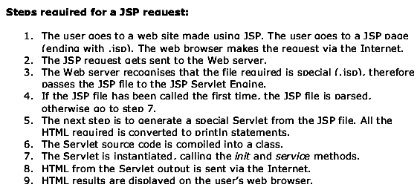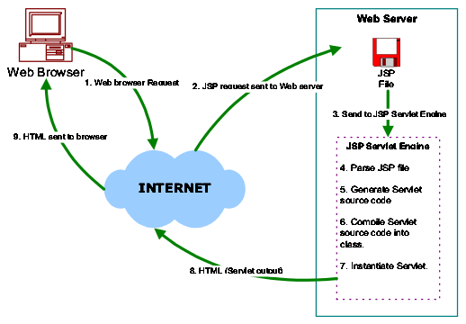

JSP Tags:

There are 5 main JSP Tags:

1. Declaration Tag
2. Expression Tag
3. Directives Tag
4. Scriplet Tag
5. Action Tag

